IMMACULATE HEART OF MARY
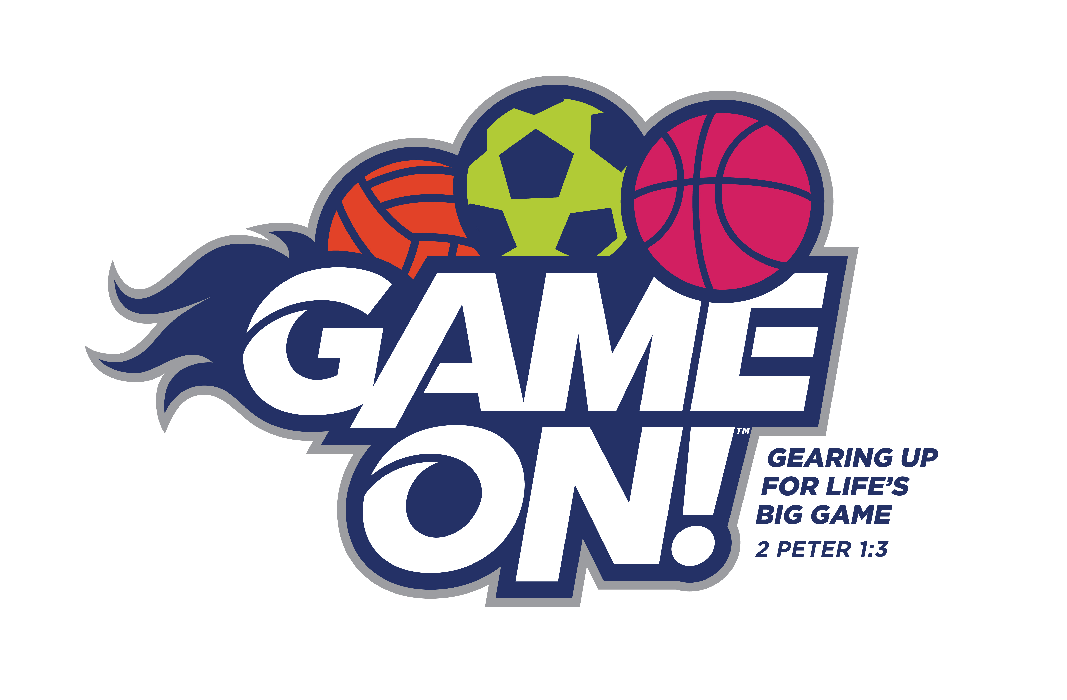
2018 VACATION BIBLE CAMP INFORMATION
WHAT: A five day fun-filled adventure with friends of all ages! Activities include SPORTS, singing and dancing, games, arts and crafts, and BIBLE STORIES!!!!!
WHO: Children who are 4 years old by July 1, 2018 through those children completing 4th grade 2017-18. Youth who have completed 5th grade may volunteer to assist with ALL aspects of VBC! Contact Lori!
WHERE: Days begin and end in the IHM Gym!!!! Fun happens in classrooms, hallways and
in the backyard!
WHEN: Monday, June25 – Friday, June 29 9:00 a.m.—12 noon
HOW: Please pay $35/child to help defray the costs of snacks, art, science and game supplies. Please complete the REGISTRATION FORM below. Detach and return the form WITH $35/child, cash or check made payable to IHM to: Faith Formation Office @ IHM via kid mail or by snail mail to 8501 Loch Raven Blvd., Towson, MD 21286.
For more information contact Lori Cuomo at 443-928-8035 or lori.cuomo@gmail.com
~ Please keep this portion for your records ~

2018 VACATION BIBLE CAMP REGISTRATION FORM
PLEASE PRINT NEATLY!
Family Last Name
Address
Email Address
Father’s Name Mother’s Name
Father’s Cell Mother’s Cell
Emergency Contact Contact Info
Child’s Full Name __ Grade Fall 2018
Child’s Full Name Grade Fall 2018
Child’s Full Name Grade Fall 2018
Would you like to volunteer? Yes  No (If yes please list availability )

